Decision support for forest management
  - Lecture 3 outline, Multi-criteria decision analysis

Introduction
- Natural resource management requires consideration of
  - multiple (often conflicting) objectives
  - the perspectives of multiple stakeholders
  - biophysical, social, and economic issues
  - several to many alternatives (potential actions)
- Given all this, effective land management requires rational and justifiable choices
- Many tools available to support decision processes (lecture 2)
  - But most only address very specific aspects
  - After we have run all the tools, there is still the problem of integrating all the analytical results
  - Ultimately, managers have to decide what actions to take where and when
- Strategic and tactical decisions in natural resource management are typical of problems that are usually too complex to rely on common sense reasoning alone
- The basic aim of decision support in this context
  - Ensure the decision maker is as informed as possible
  - Organize and present information about the problem in a way that facilitates the decision
    - And document the decision!
- Decision support systems are NOT meant to make decisions
  - That’s why we have decision makers
  - George Box (ca 1987) – “All models are wrong, but some are useful.”
  - All models are simplifications of reality

Multi-criteria decision analysis (MCDA)
- Most MCDA solutions cannot fully satisfy all the objectives
- MCDA attempts to balance objectives so as to maximize the benefits (or minimize the costs) given what is known about the decision context
- A basic objective of the analysis is to identify the best alternative
  - Based on a set of rational standards
    - Prescriptive
    - Normative
- Phases of an MCDA process
  - Structure the problem
  - Assess consequences of the alternatives
  - Determine preferences of the decision makers
    - Many (not all) OR methods ignore preference
  - Evaluate and compare the performance of alternatives
- Utility is a central concept
  - E.g., how useful is an alternative with respect to satisfying the goal or objective?
  - Utility is the underlying basis for rational choice
    - A subjective measure of desirability
    - Usually can’t be expressed in physical quantities
  - In a rational model, we should select the alternative with the highest utility
- Types of priorities
  - Ordinal – outranking methods like PROMETHEE
  - Cardinal – interval scale of priorities - Analytic Hierarchy Process
    - Supports sensitivity analysis and tradeoff analysis

Analytic Hierarchy Process (AHP)
- Most decision making problems involve preferential choices among a set of alternatives
  - Alternatives might be objects, events, or courses of action
- Types of decisions (a progression)
  - I want to buy a car and the only criterion is purchase price – simple
  - I want to buy a car and the only criteria are economic – a little math
    - Purchase price
    - Cost to operate
    - Cost to maintain
    - Cost to fix
  - I want to buy a car, and I care about cost (of course), but I also care about style and performance
    - Now we have a problem!
    - The criteria are incommensurate – no single scale
    - The AHP was designed to handle this kind of case.
- Basic steps of the AHP process
  - Structure the problem (goals, criteria, subcriteria…)
  - Pair-wise compare the elements contributing to the next higher level in terms of their contribution (importance) with respect to the next higher level (see below)
    - These are local priorities.
  - Synthesize the local priorities across all levels of the hierarchy to derive global priorities
- Ratings for pair-wise comparisons (Saaty 1980)
  - 1-9 scale
    - 1 means A and B are equally important
    - 3 means A is weakly more important than B
    - 5 means A is strongly more important than B
    - 7 means A is very strongly more important than B
    - 9 means A is absolutely more important than B
  - Geometric interpretation
    - 5 means A is five times than B
- Modes of comparison – ratings can be interpreted as…
  - Preference
  - Importance
  - Likelihood
  - Others

Example: choosing a high school
- The model structure
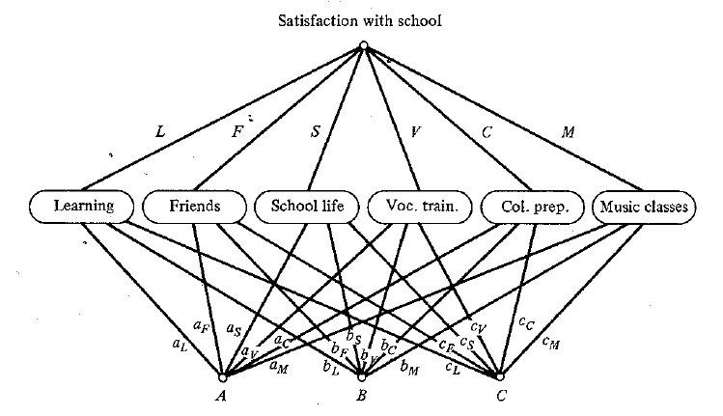
- Pair-wise comparisons among the criteria with respect to school satisfaction
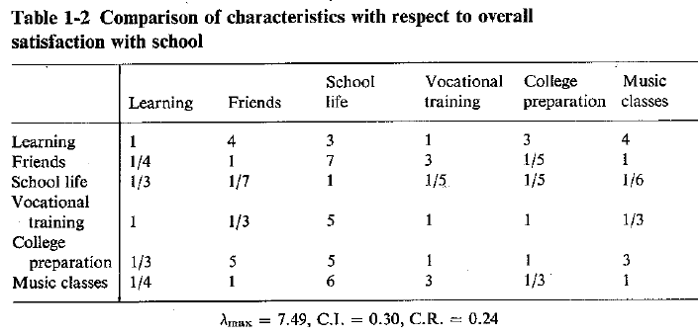
  - The weights on criteria are derived as the right principal eigenvector of this matrix (Saaty 1980).
  - λ_{max} is the eigenvalue associated with the right principal eigenvector
    - Variance accounted for by the eigenvector
  - CI is the consistency index = (λ_{max} – n)/(n -1), where n is the trace of the matrix
  - CR is the consistency ratio = CI/RI, where RI is the random index (a look up)
    - Here, for n=6, RI=1.24, and CR=0.30/1.24=0.24
    - We want CR≤0.10
    - Ideally, we’d like λ_{max} = n, in which case CR=0 (perfect consistency)
  - For the high school example, the resulting weights (priority vector) are
(0.32, 0.14, 0.03, 0.13, 0.24, 0.14)
- In the “classic” AHP process, the pair-wise process is repeated down to the level of the alternatives
  - E.g., alternatives are pair-wise compared with respect to the lowest level criteria.
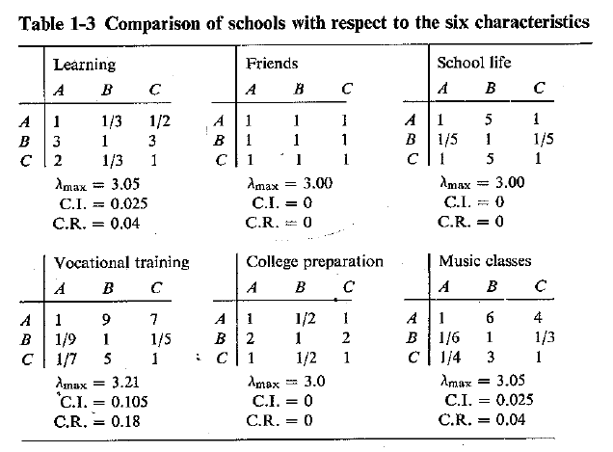
  - In table form, we can write the eigenvectors as
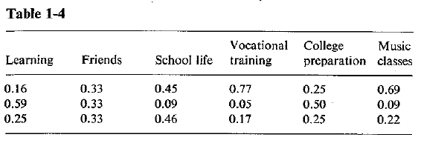
A row for each of the schools, A, B and C
  - The synthesis step
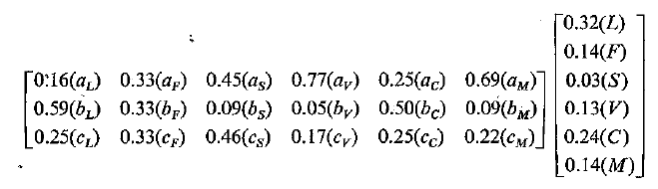
  - Carrying out the matrix multiplication, we get
    - A=0.37
    - B=0.38
    - C= 0.25
  - Does a completely rational decision suggest we should pick school B?
    - Recall, with a model based on cardinal priorities, we can do things like sensitivity analysis
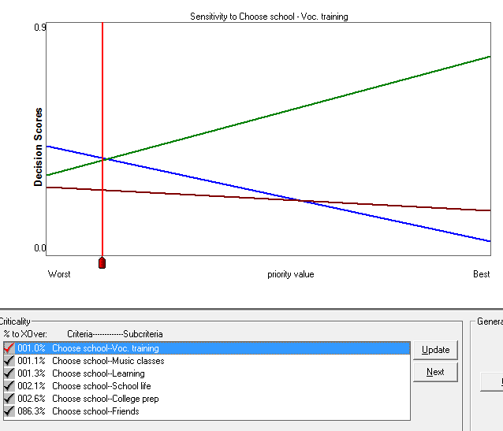
    - What does this figure tell us?
    - We can also look at how the criteria contribute to the overall score
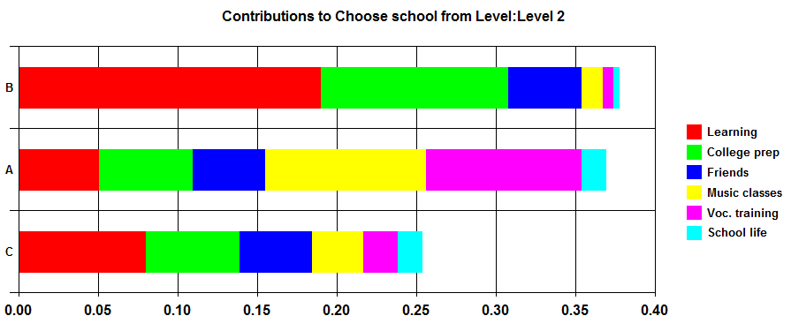

- Distributed versus ideal model forms
  - Notice, in the final priority scores for schools, the priorities sum to one
  - This is referred to as a distributed model, because we fully allocate the maximum possible score of 1 among the alternatives
  - Saaty (1980, 2001) argues that, if the objective is to select a best alternative, then the distributed form is preferred
  - Below, we look at AHP models that integrate SMART, which is preferred under some situations (ideal model)
- Rank reversal in the classic AHP model
  - Occurs when alternatives are pair-wised compared
  - Directly related to the distributed AHP form
  - Hotly debated in the literature, especially in the 1990s!
  - The phenomenon
    - When alternatives are added or deleted, the relative ordering of other alternatives can be altered

A walk through a CDP model
- Example: “regional fuels priority w data.cdp”
- Developed by/for senior managers at US Forest Washington Office national headquarters
  - Roles
- We will walk through first, then build this model together
- The basic hierarchy
  - Goal
  - Criteria – the basic objectives to satisfy the goal
  - Sub-criteria – more specific details that support an objective
    - In general, more specificity as you move down the hierarchy
  - Lowest level criteria = attributes
  - Alternatives, in this case USFS Regions
- Comments
  - Documenting the model
  - Reasoning
  - Metadata
- Ratings on criteria
  - Full pair-wise (goal)
  - Abbreviated pair-wise (criteria)
  - Direct ratings (no examples)
- Ratings on attributes
  - Recall the high school example – alternatives compared to each other with respect to the attributes
  - Here we use the Simple Multi-attribute Rating Technique (SMART)
    - Externally defined, absolute reference scales
  - Advantages of SMART in environmental context
    - Needed in a spatial context when there can be hundreds of alternatives
    - For biophysical attributes, it is often not hard to specify objective standards
      - But ordinal attributes are ok too
      - E.g., forest patches on a forest management unit
    - Minimizes the rank reversal problem
    - Accounting for uncertainty in the attribute values
  - SMART utility functions in CDP
- CDP analysis products
  - Decision scores
    - Utility of the alternative with respect to satisfying the goal
  - Contributions
    - How criteria contribute to the goal
    - How sub-criteria contribute to their parent criterion
  - Sensitivity analysis
    - How sensitive is the model to the weights?
    - If not sensitive, then robust
    - Rule of thumb – 10%
  - Tradeoff analysis
    - How a unit change in one attribute trades for others
      - Given the weights and attribute values
    - A reality check on the model weights
  - Other outputs
    - Uncertainty analysis
    - Scatter plots

Building the fuels treatment CDP model
- Hands on
- Instructor led
- A basic roadmap

Readings
Murphy, P.J. 2014. Criterium DecisionPlus. Chapter 3 in Reynolds, K.M., P.F. Hessburg, and P.S. Bourgeron (eds). Making Transparent Environmental Management Decisions: Applications of the Ecosystem Management Decision Support System. Berlin: Springer.
Saaty, T.L. 1980. The Analytic Hierarchy Process. McGraw Hill: New York. (Chapter 1)
Schmoldt, D.L., J. Kangas, and G.A. Mendoza. 2001. Basic principles of decision making in natural resources and the environment. Pages 1-3 in Schmoldt, D.L., J. Kangas, G.A. Mendoza, and M. Pesonen (eds.) The Analytic Hierarchy Process in Natural Resource and Environmental Decision Making. Kluwer Academic Publishers: Dordrecht.

Additional references
Saaty, T.L. 2001. Fundamentals of the Analytic Hierarchy Process. Pages 15-35 in Schmoldt, D.L., J. Kangas, G.A. Mendoza, and M. Pesonen (eds.) The Analytic Hierarchy Process in Natural Resource and Environmental Decision Making. Kluwer Academic Publishers: Dordrecht.
Keeney, R.L. 1982. Decision analysis: an overview. Operations Research 30: 803-838.
Keeney, R.L. 1988. Value-driven expert systems for decision support. Decision Support Systems 4: 405-412.

